SARA Invoice Status Tool
Quick Reference Guide
Purpose: This document provides instructions for using the Statement Account Reconciliation Automation (SARA) tool to obtain status of invoices.
Audience: Ascension suppliers

Table of Contents
About SARA 1
Acessing the SARA Template 1-2
Filling Out the SARA Template 2-3
Reviewing SARA Results 3

About SARA
- The Statement Account Reconciliation Automation (SARA) tool allows suppliers to use an Excel template to submit a list of invoices and receive an update via email with the status of each invoice. Responses are provided within 1 business day from the date of submission.
- SARA uses automation technology to search in multiple Ascension systems to provide the most up-to-date status on all invoices.
- SARA only uses the information you have entered into the spreadsheet fields that are marked (Required Field) to search for invoices. The SARA template must be formatted correctly for the automation to successfully provide information. Please do not modify header column labels or change any other formatting on the template prior to submitting it.
- SARA is an invoice status inquiry tool and only provides information about the current status of invoices that are in our system. SARA does not take any follow up actions related to unpaid invoices.
- SARA is 100% automated, and any messages submitted to autostatementreconcil@ascension.org that do not include an appropriately formatted SARA Excel template will be discarded. Please ensure that any follow up inquiries about invoices are submitted through the appropriate channels.
Accessing the SARA Template
- Navigate to the Ascension Supplier Portal at https://supplierportal.ascension.org.
- Click the Inquire about Invoices button.
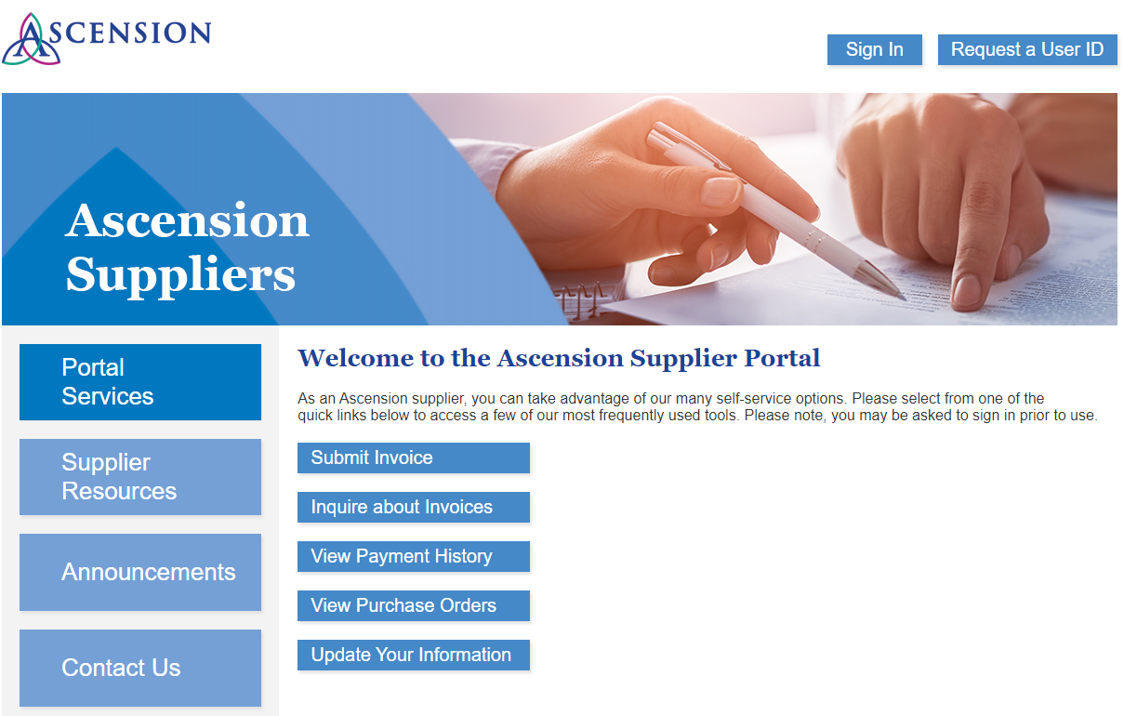
- You will be prompted by your browser to open the SARA Excel template. Click Open.
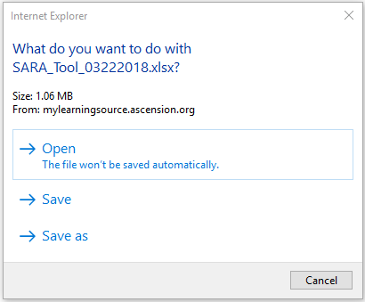
- Save the SARA template Excel file locally to your computer.

Filling Out the SARA Template
- Complete the fields on the template that are marked as (Required Field). Enter information in the empty cell(s) below the field label.
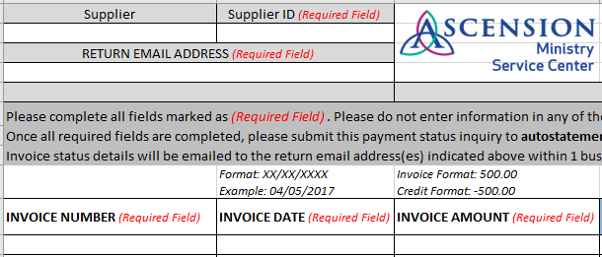
  - Enter your 10-digit Supplier ID number in the Supplier ID field.
Example:
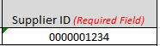
  - Enter the email address(es) where you want the invoice status results to be sent in the RETURN EMAIL ADDRESS field. Multiple email addresses can be entered separated by commas with no spaces.
Example:
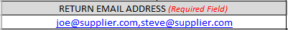
  - Enter the invoice numbers in the INVOICE NUMBER column. Please be sure that the invoice number matches the number that is printed on your company’s invoice documents to ensure more accurate search results (ex. if the invoice number on the invoice document includes leading zeros, these must but included for SARA to locate the invoice).
Example: 0005246583
  - Enter the invoice dates in the INVOICE DATE column in the following format: MM/DD/YYYY
Example: 04/05/2017
  - Enter the invoice amounts in the INVOICE AMOUNT column in the following formats for invoices and credit memos:
Invoice: 500.00
Credit Memo: -250.00
- NOTE: Please be sure to enter the full amount of the invoice or credit. If the invoice was short paid, please do not enter the remaining balance due as SARA will be unable to locate the invoice in our system if the amount you provide does not match the total amount printed on the invoice document.
- If you need assistance with the remaining balance for a short paid invoice, please submit a self-service case. Include the invoice number, the 15-digit PO number related to the invoice, and any additional information related to the balance due.
- The PO Number column is optional. Remember that all invoices require a valid 15-digit Ascension PO number for payment processing.
- Please do not enter information in any of the other fields on the SARA template. Modifying the formatting or adding additional information in fields that are not marked as Required may cause the automation to fail.
- After you have completed the required fields, email the completed SARA template as an attachment to autostatementreconcile@ascension.org. The template must be submitted in Excel format.
- SARA will provide a response to your inquiry within 1 business day to the email address(es) you indicated on the template. Please note that SARA is entirely automated, so only information entered in the required fields on the template is used for this search process. Any details in the body of the email or additional attachments will not be read and will not be returned on the results that SARA provides back to you.

Reviewing SARA Results
- The response email from SARA will come from AHMSC-MB-Auto Statement Reconcile (autostatementreconcile@ascension.org). The status results for the invoices will be in an Excel spreadsheet attachment.
- Open the attachment and review the information in the column labeled NOTES FROM SARA to see the status of each invoice.
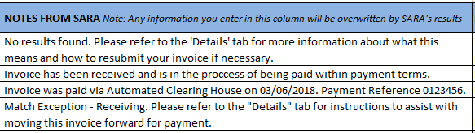
- Click the plus sign (+) above the N column on the spreadsheet to see additional details about paid invoices.
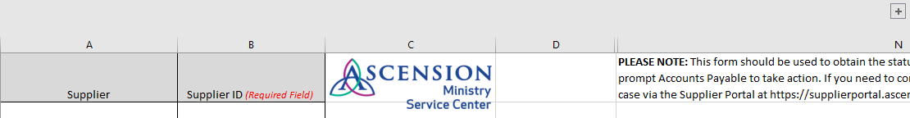
- The plus sign will expand additional columns that include the payment reference number, payment date, payment method, payment amount, and remit address.
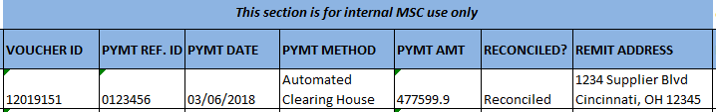
- If the invoice has not been paid and the note instructs you to refer to the “Details” tab for more information, click the Details tab at the bottom of the Excel file.
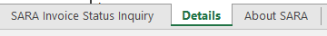
- The Details tab provides additional information about issues that could cause a delay in payment processing for the invoice. The information on this tab may also instruct you to take action to help move the invoice forward.
- Please find the row that matches the Invoice Status from the NOTES FROM SARA column and review the information.
- Review the information in columns B and C, What This Means and How The Invoice Is Resolved.
- The column labeled What The Supplier Can Do may include instructions for action that is needed from you to help resolve the invoice.
- If you need additional information about an invoice or payment, please submit a self-service case. Include the payment number, invoice number, PO number, and any other details or inquiries about the payment.

